By Chunsheng Ji @ 8/10/2017

Setting up a Scala Spark development environment with Maven

1. Install latest JAVA jdk

<http://www.oracle.com/technetwork/java/javase/downloads/jdk8-downloads-2133151.html>

1. Install IntelliJ IDEA

Download and install IntelliJ IDEA (Community) :

<https://www.jetbrains.com/idea/download>

1. Add Scala and Spark
   1. Open IntelliJ, in the welcome page, select Configure > Plugins

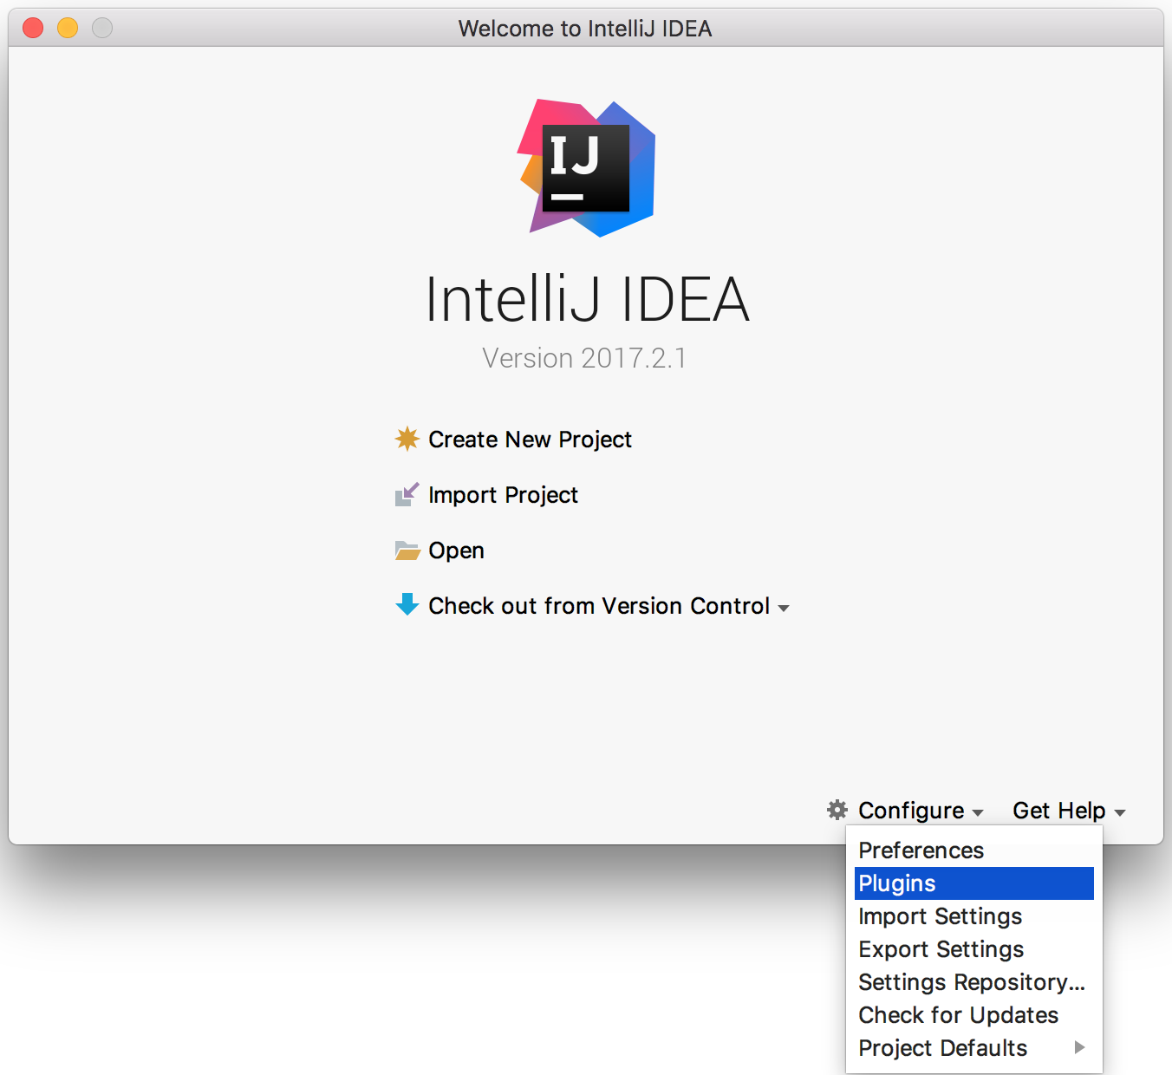

* 1. Select Browse Repositories to search for and install Scala. Restart IntelliJ as requested.

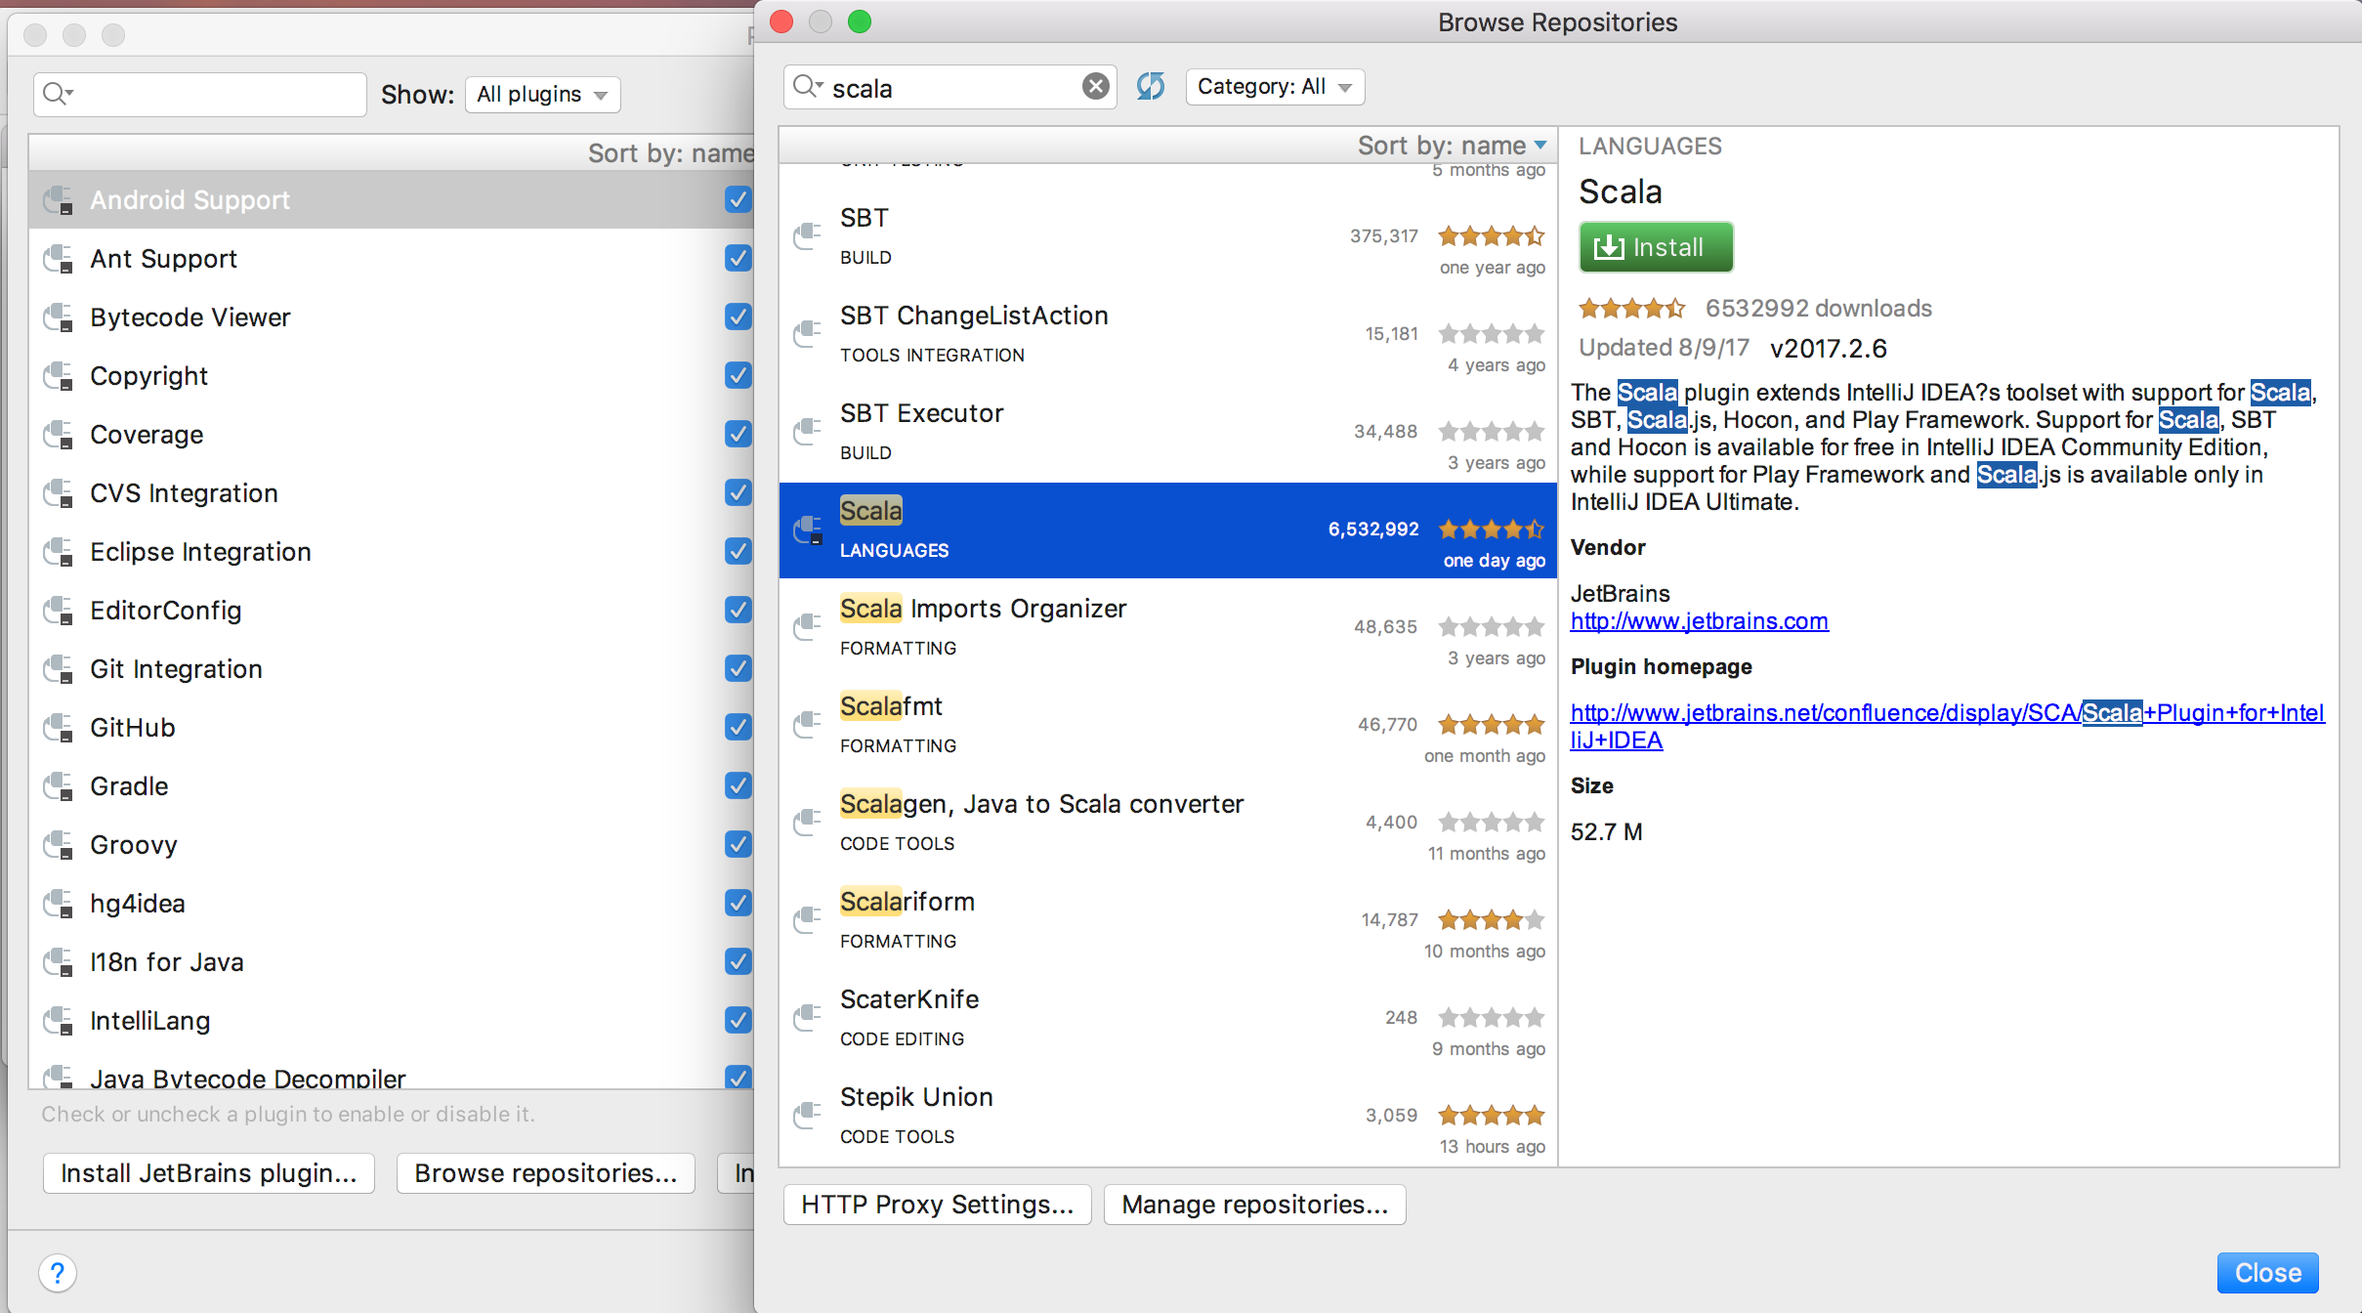

* 1. Select Create New Project > Maven. Select Create from archetype > org.scala-tools.archetypes:scala-archetype-simple

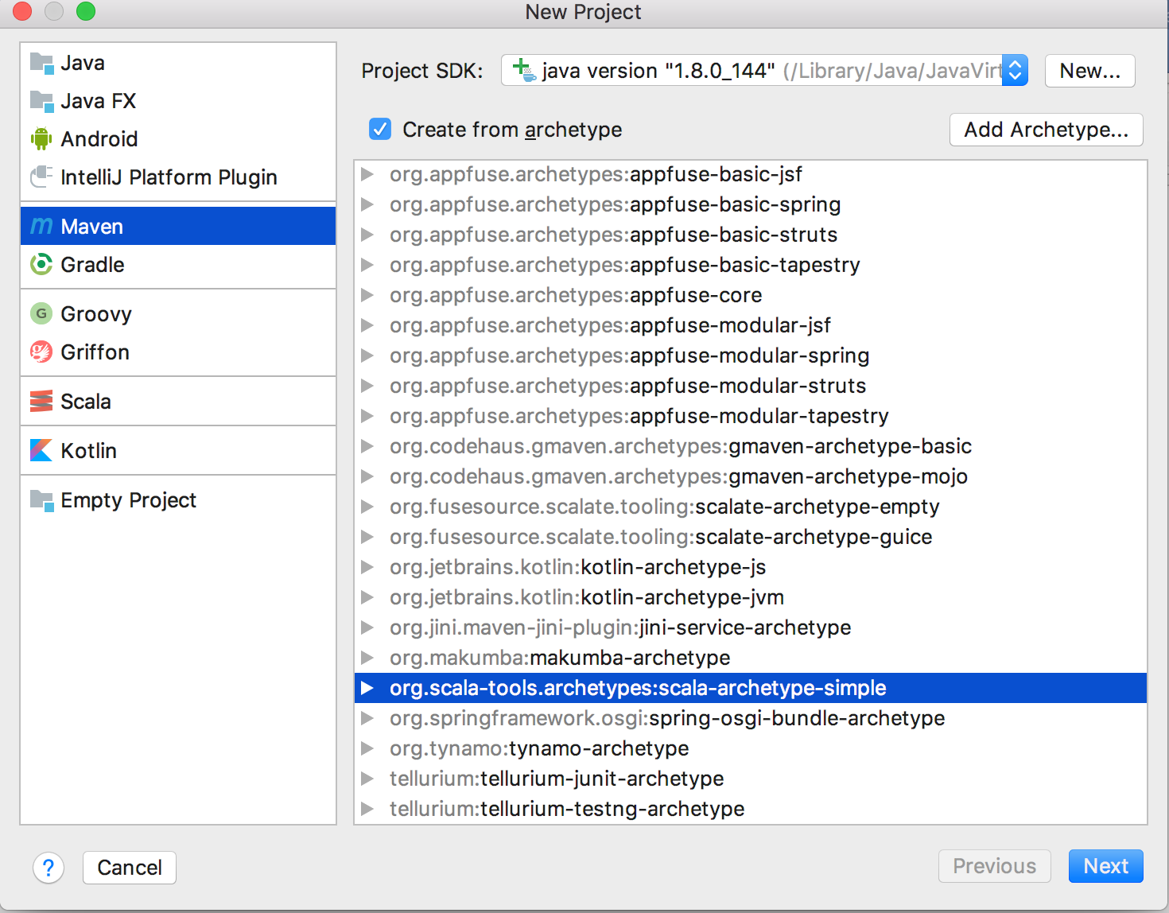

* 1. Create new project by setting GroupId, ArtifactId, and Version.

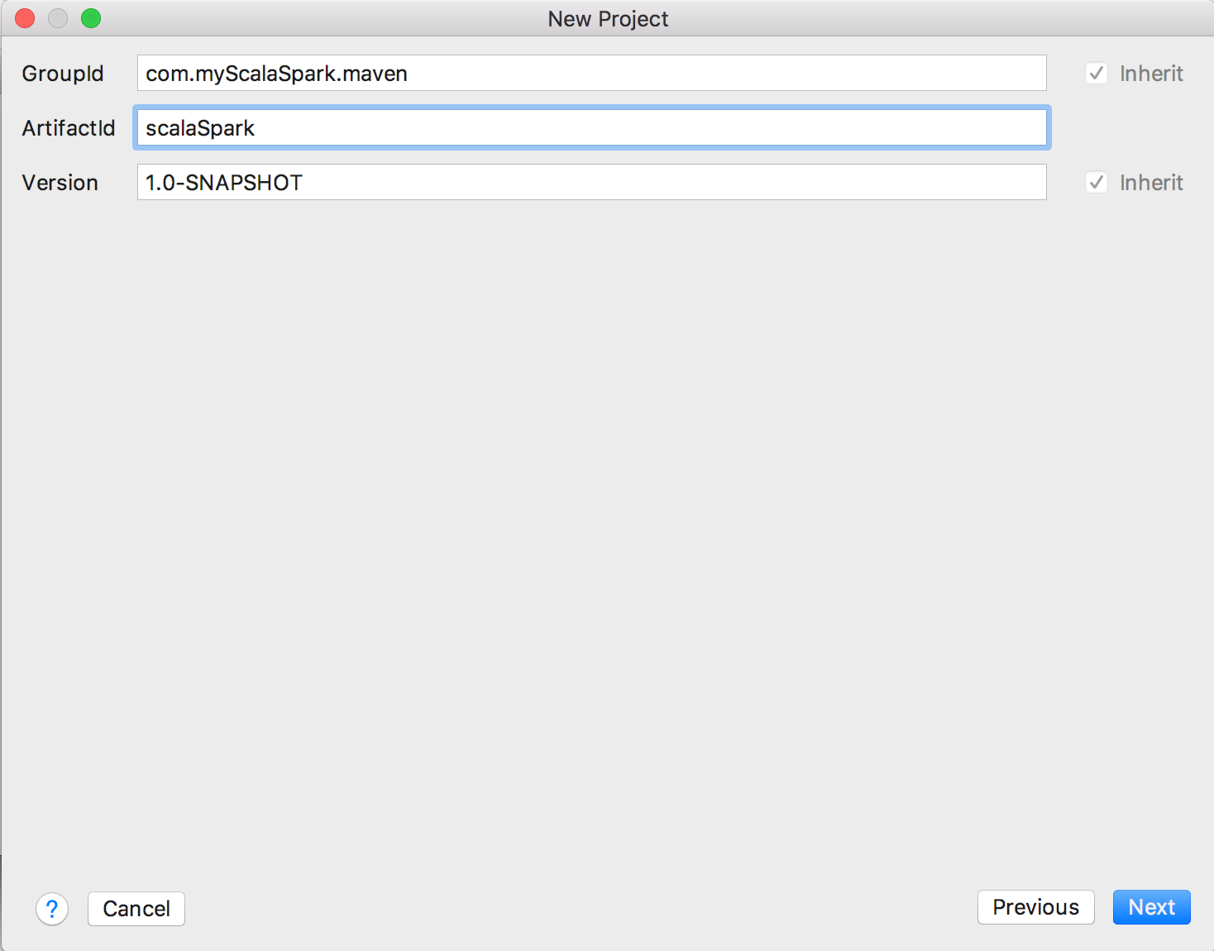

* 1. Use default Bundled Maven 3

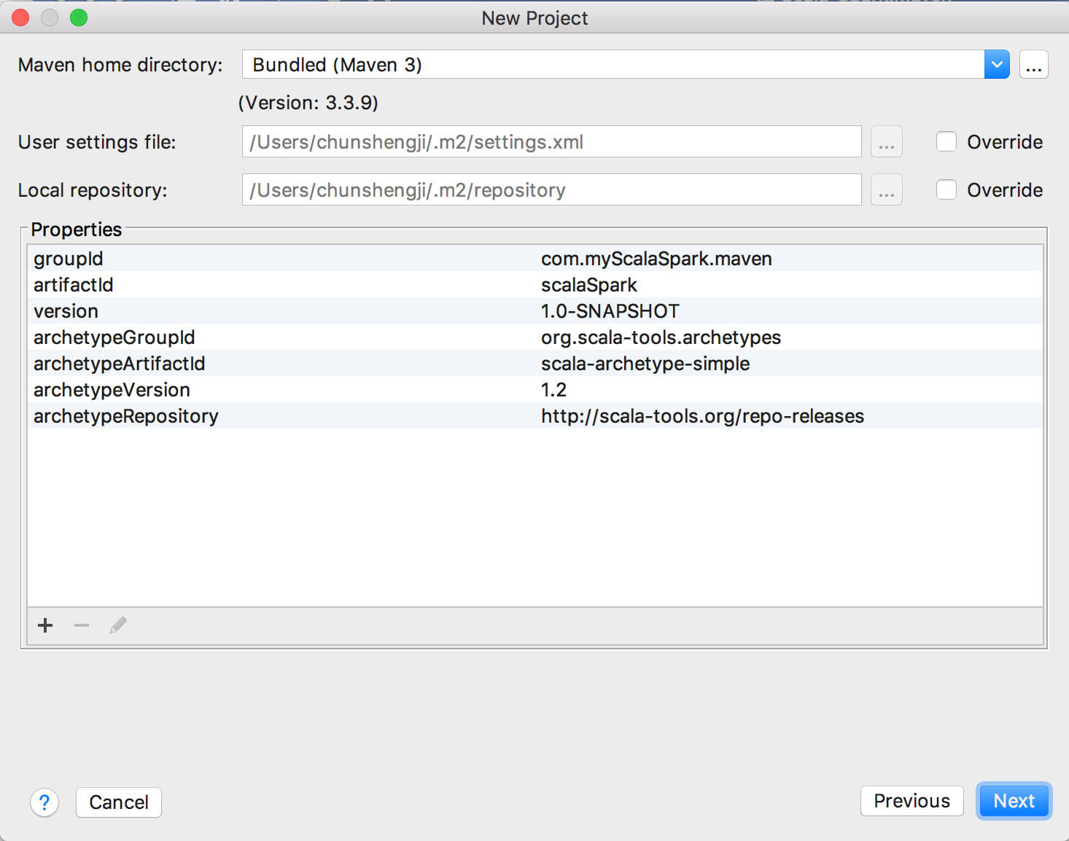

* 1. Finish creating a new project

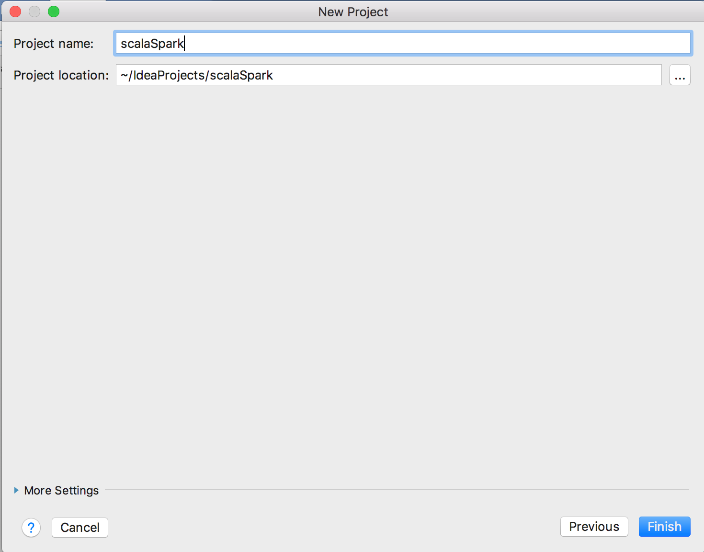

* 1. Add Scala SDK. Select File > Project Structure

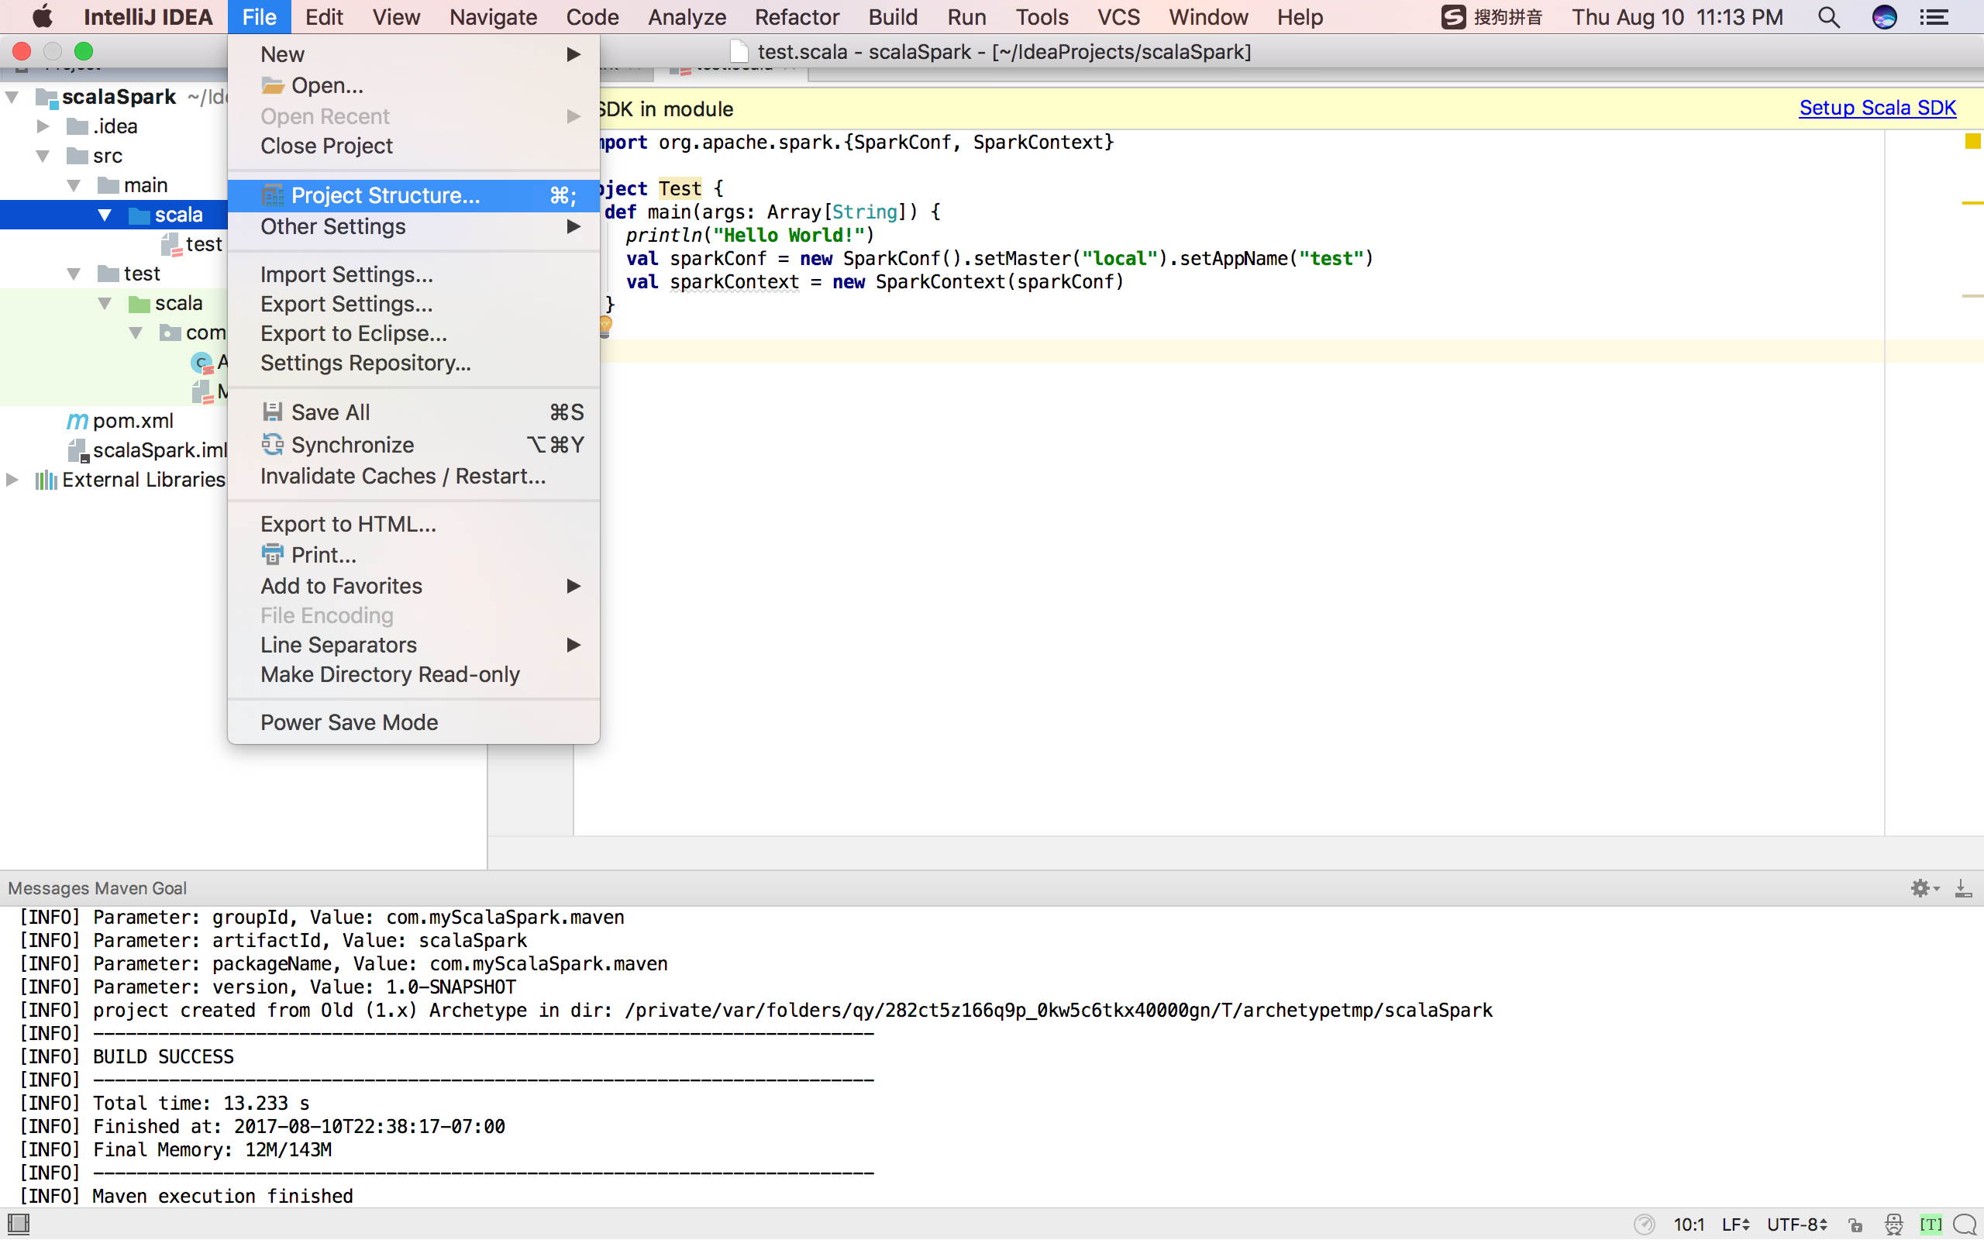

Select Libraries > + > Scala SDK > Download. Select the latest version, download and install.

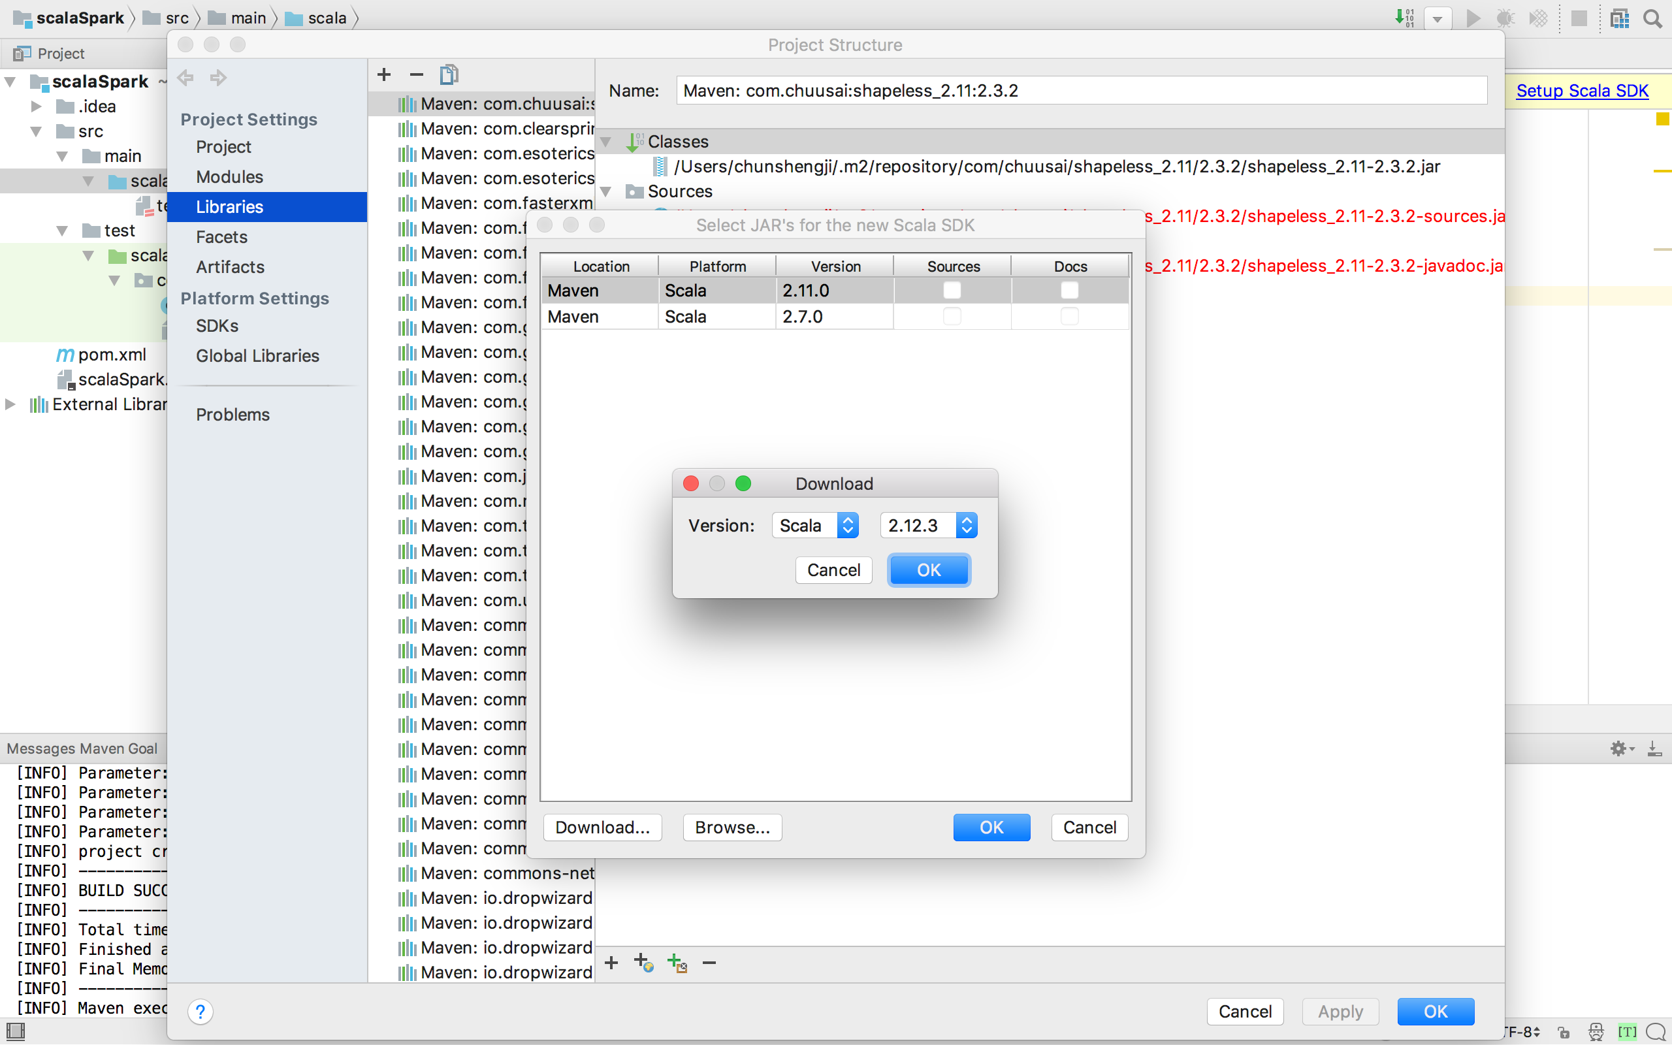

* 1. Select pom.xml and add the following dependencies for Spark

|  |
| --- |
| <**dependency**>  <**groupId**>org.apache.spark</**groupId**>  <**artifactId**>spark-core_2.11</**artifactId**>  <**version**>2.2.0</**version**> </**dependency**> <**dependency**>  <**groupId**>org.apache.spark</**groupId**>  <**artifactId**>spark-sql_2.11</**artifactId**>  <**version**>2.2.0</**version**> </**dependency**> <**dependency**>  <**groupId**>org.apache.spark</**groupId**>  <**artifactId**>spark-mllib_2.11</**artifactId**>  <**version**>2.2.0</**version**> </**dependency**> <**dependency**>  <**groupId**>org.apache.spark</**groupId**>  <**artifactId**>spark-graphx_2.11</**artifactId**>  <**version**>2.2.0</**version**> </**dependency**> |

Check the following link to make sure you are using the most recent version.

<https://mvnrepository.com/artifact/org.apache.spark>

Don’t forget to Import Changes (may take couple of minutes).

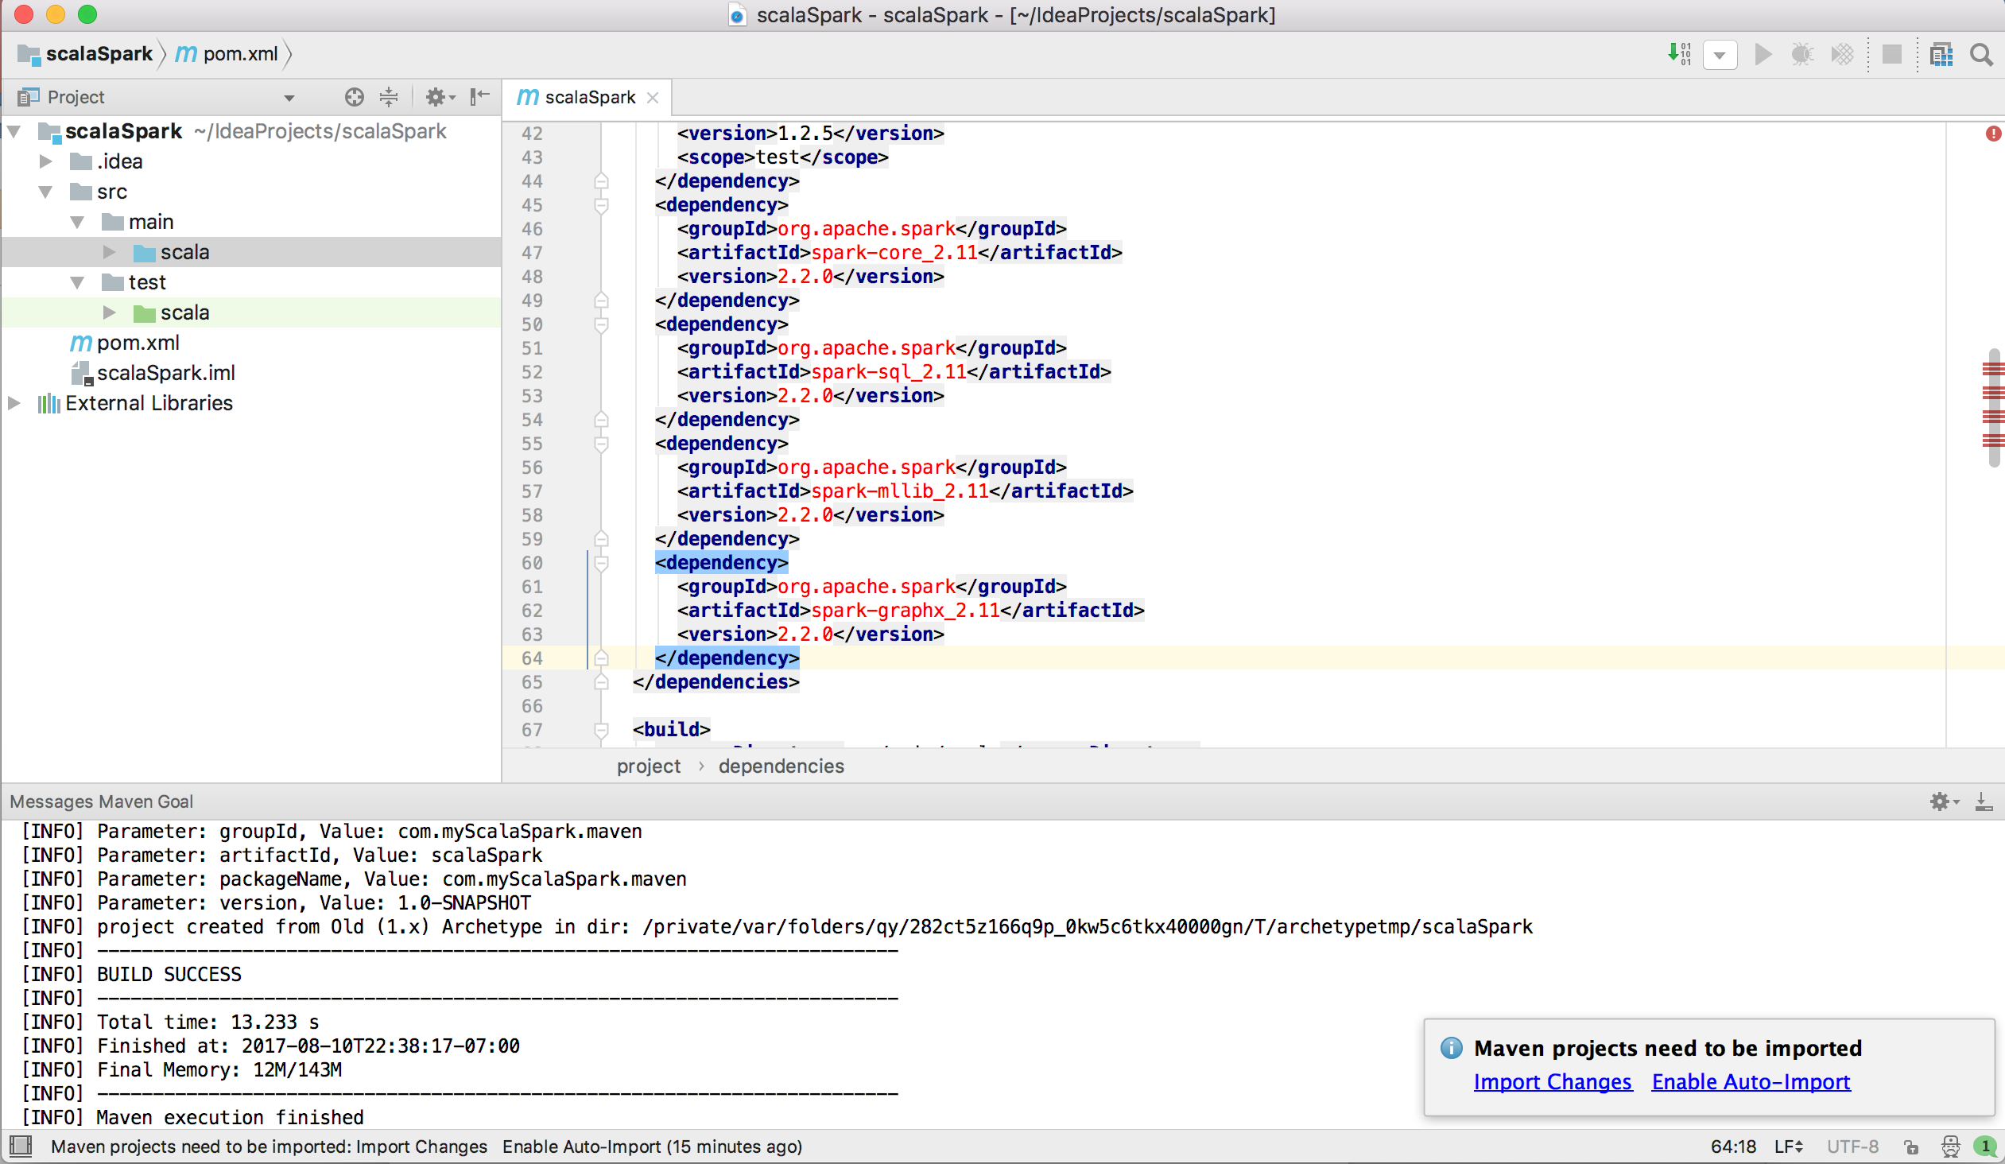

1. Create your first Scala-Spark “Hello World!”

(before creating your own Scala file, you can delete the directory under src > main > scala and src > test > scala)

* 1. In your project, select src > main > scala, right click and select New > Scala Class

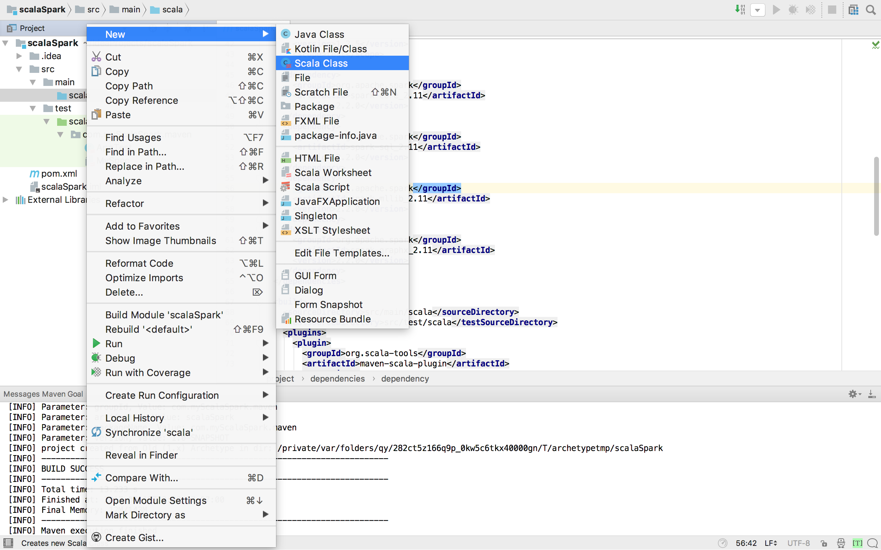

* 1. Name the Scala file and select Object.

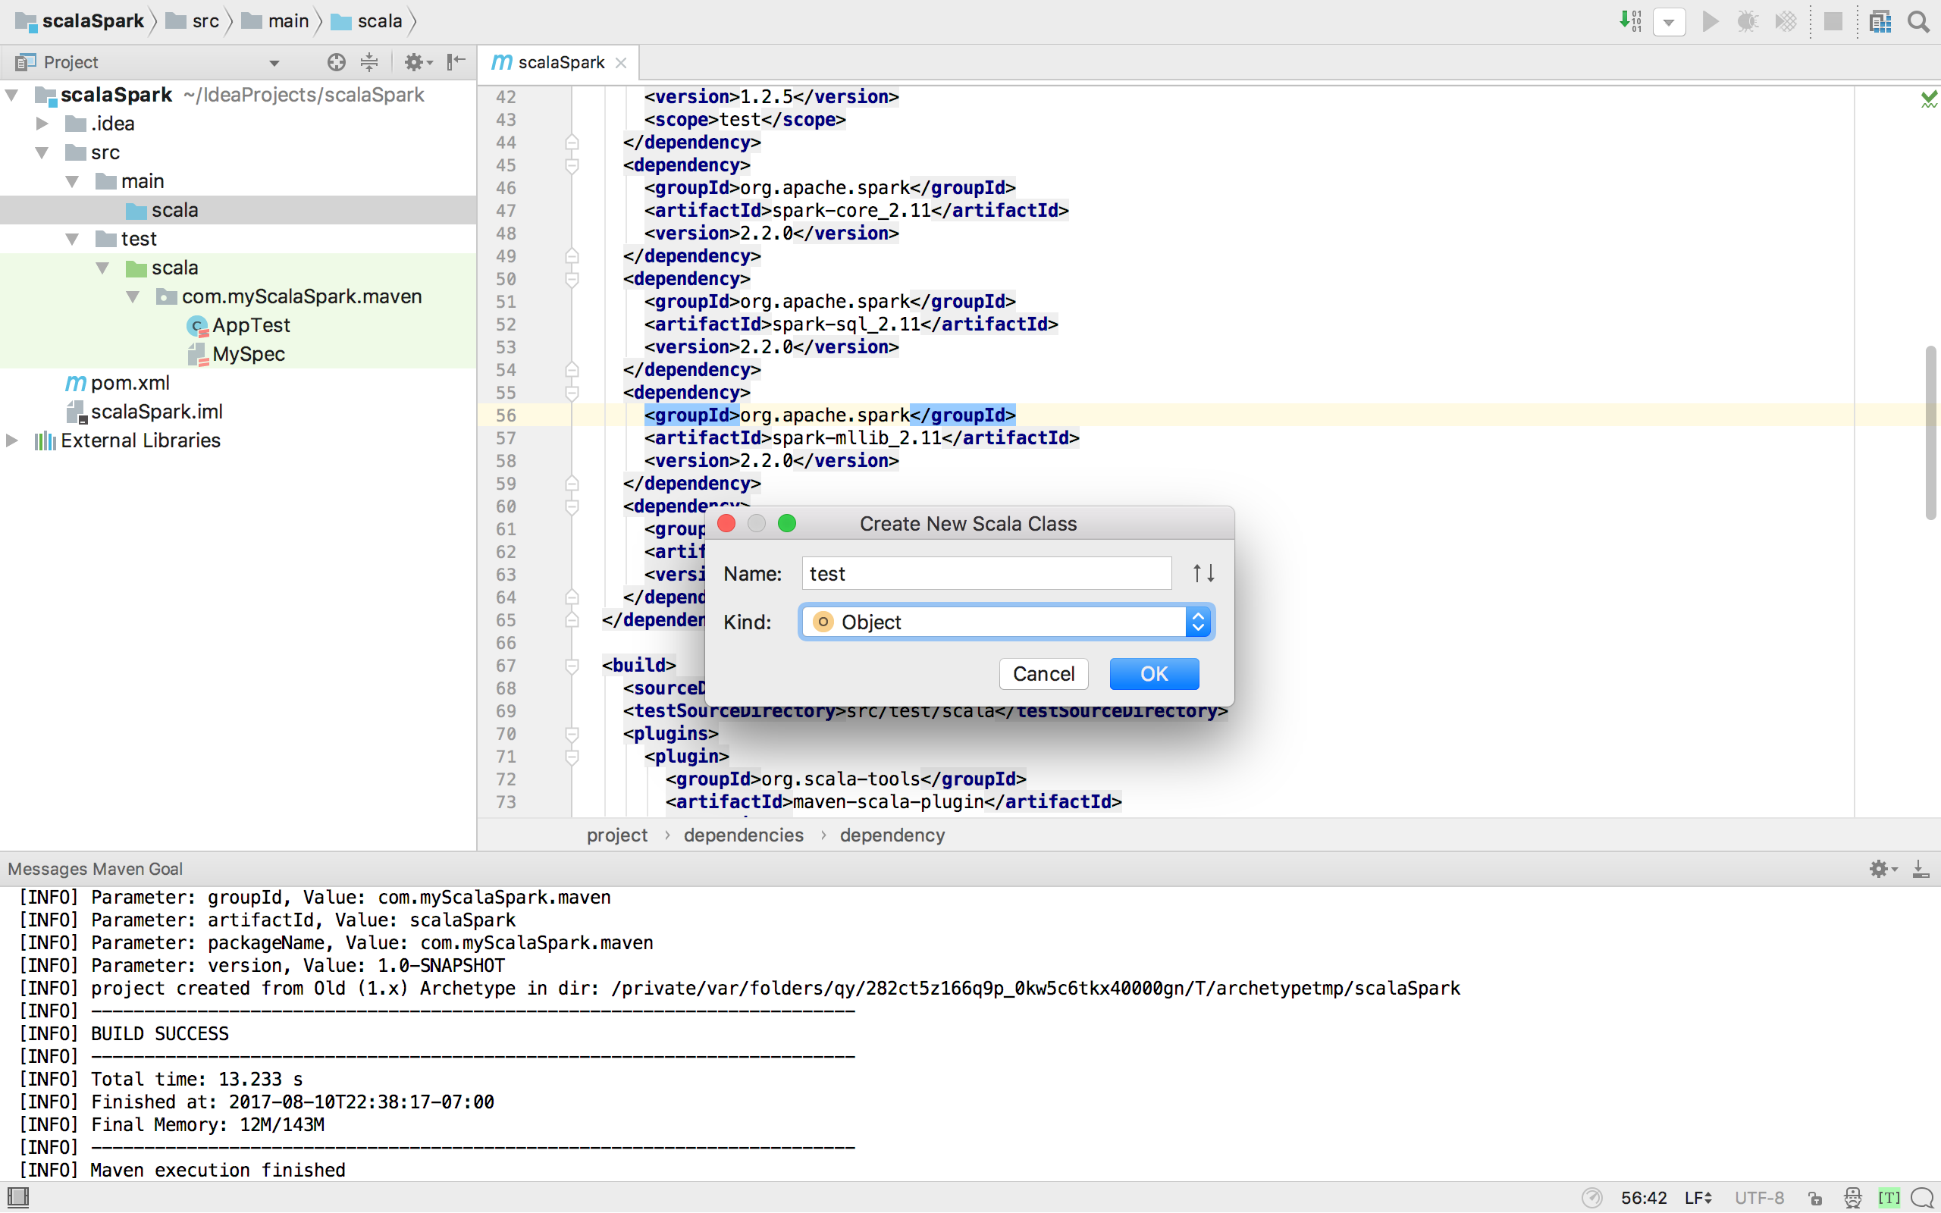

* 1. Below is your first Scala file with Spark. Right click and select Run ‘Test’.

|  |
| --- |
| **import** org.apache.spark.{SparkConf, SparkContext}  **object** Test {  **def** main(args: Array[String]) {  **val** sparkConf = **new** SparkConf().setMaster(**"local"**).setAppName(**"test"**)  **val** sparkContext = **new** SparkContext(sparkConf)  *println*(**"Hello World!"**)  } } |
|  |

* 1. You should see something like this.

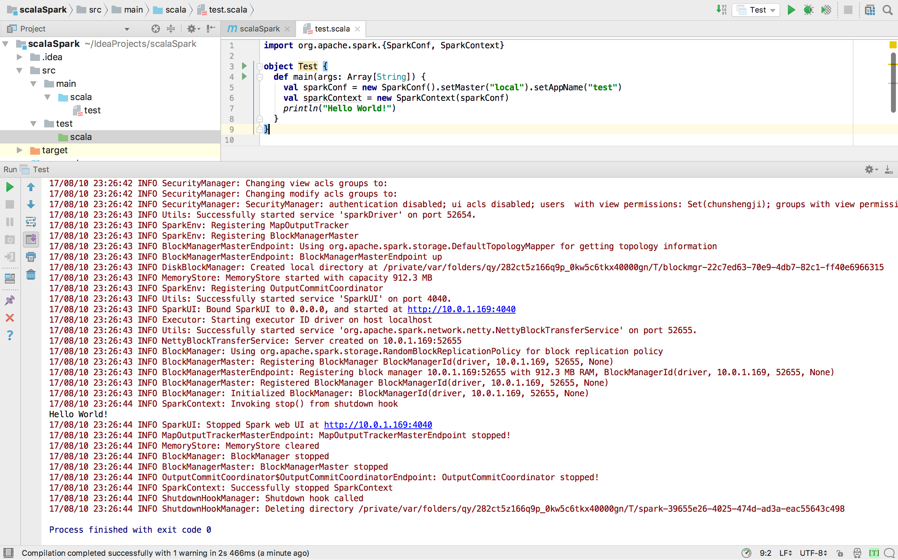

Congratulations! You are done.